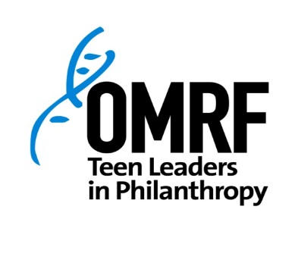
2017-2018 Program Calendar
A meal and snacks will be provided at each session.
All sessions will be held at OMRF. See map for specific parking and entrance details.
Tuesday, September 12 | ORIENTATION | 12:30-5pm
Tuesday, October 10 | Session 2 | 12:30-5pm
Tuesday, November 14 | Session 3 | 5:30-8pm
December: NO SESSION
Tuesday, January 9 | Session 4 | 12:30-5pm
Tuesday, February 13 | Session 5 | 5:30-8pm
Tuesday, March 6 | Session 6 | 5:30-8pm
April 7 | Project/Event! | TBD
April 10 | Graduation Party | 6:00-7:30pm
Parking for participants in North Garage at NE 15th/Phillips.