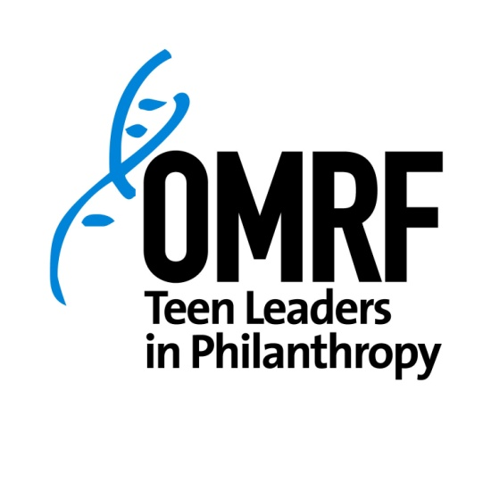
2015-2016 Program Calendar
Tuesday, September 8 | ORIENTATION | 12-5pm
Tuesday, October 13 | Session 2 | 5:30-8pm
Tuesday, November 10 | Session 3 | 12-5pm
December: NO SESSION
Tuesday, January 12 | Session 4 | 12-5pm
Tuesday, February 9 | Session 5 | 5:30-8pm
Tuesday, March 8 | Session 6 | 5:30-8pm
April 2 | Project/Event! | TBD
April 5 | Graduation Party | 5:30-7:00pm

A meal will be provided at each session.
All sessions will be held at OMRF except the graduation party, which will be held at a private home in Oklahoma City. Address is forthcoming!

